APT Project Report – Phase 1: Project Definition
Project Name: MejorSol
Degree Program: Computer Engineering
Campus: Viña del Mar

1. Personal Background
Student Name | ID Number (RUT)
Fernando Cisternas | 20.795.198-6
Isai Farias | 21.249.224-8
Erick Toledo | 20.408.656-7

2. APT Project Description
Project Name: MejorSol
Areas of Professional Practice:
- Creation and querying of databases
- Web page development
- Data analysis and business statistics development using data mining or big data
- AI implementation
Project Overview:
The MejorSol project aims to develop a technological platform for Sieer, a Chilean company dedicated to the sale, distribution, and maintenance of solar panels. This platform will centralize customer, product, and sales data, integrate data analysis tools, and implement an AI-powered chatbot to enhance customer experience.

3. APT Project Justification
Relevance of the APT Project:
The current system used by Sieer is based on Office tools and a Wix website, which is inefficient for business management. MejorSol will provide a comprehensive technological solution that:
- Automates product, customer, and sales registration
- Provides data analysis tools to optimize inventory management and commercial strategies
- Incorporates an intelligent chatbot to improve customer experience
Description of the Project:
Develop a technological solution to improve Sieer’s website and implement a management platform to centralize data, include analytics, and an AI-powered chatbot to optimize internal processes.
Appropriateness with Graduate Profile:
The project aligns with the Computer Engineering graduate profile by addressing competencies such as:
- Offering IT solutions based on organizational process analysis
- Developing software solutions and maintaining scalable systems
- Building data models to support organizational requirements
- Implementing systemic solutions for process automation
- Transforming data into actionable information
- Managing IT projects from planning to delivery
Relation to Professional Interests:
The team’s interest in data science, AI, and database management aligns with project objectives, allowing development of competencies relevant to the current job market.
Feasibility of Project Development:
- The project fits within a 3-month semester using Scrum methodology
- Uses free or academic software tools and cloud resources
- External support from Sieer facilitates development
- Mitigation of risks through scheduled meetings, documentation, and module assignment

4. Objectives
General Objective:
Develop and implement a comprehensive technological solution that incorporates an AI-powered chatbot to optimize the management of customers, products, and sales for Sieer.
Specific Objectives:
1. Design and create a structured database to centralize customer, product, and sales information.
2. Develop a functional and visually appealing website to enhance digital presence.
3. Implement an AI-powered chatbot for customer service and innovation.
4. Apply data analysis techniques to generate reports and dashboards for strategic decision-making.
5. Integrate all modules into a unified technological platform ensuring usability, scalability, and security.

5. Methodology
Approach: Agile Scrum methodology due to its iterative, flexible nature and focus on continuous delivery.
Stages:
1. Kick-off and Product Backlog Definition: Gather requirements and prioritize functionalities
2. Sprint Planning: Select tasks for development, estimate effort, assign responsibilities
3. Development and Daily Scrum: Technical work progress, daily coordination meetings
4. Sprint Review: Demonstrate functionalities to client, gather feedback
5. Sprint Retrospective: Evaluate Sprint performance, identify improvements
6. Testing, Validation, and Final Delivery: Functional testing, error correction, final documentation
Roles:
- Eric Toledo – Product Owner
- Isai Farías – Scrum Master
- Fernando Cisternas – Developer

6. Evidence
Type of Evidence: Interview
Evidence Name: 1st Client Meeting Team
Description: The first meeting with the owner and manager of Sieer company is held to understand the company context, its functions, learn about the client’s problems, and gather some of the requirements.
Justification:
1. Requirements gathering
2. Company context
3. Discovering problems

7. Work Plan
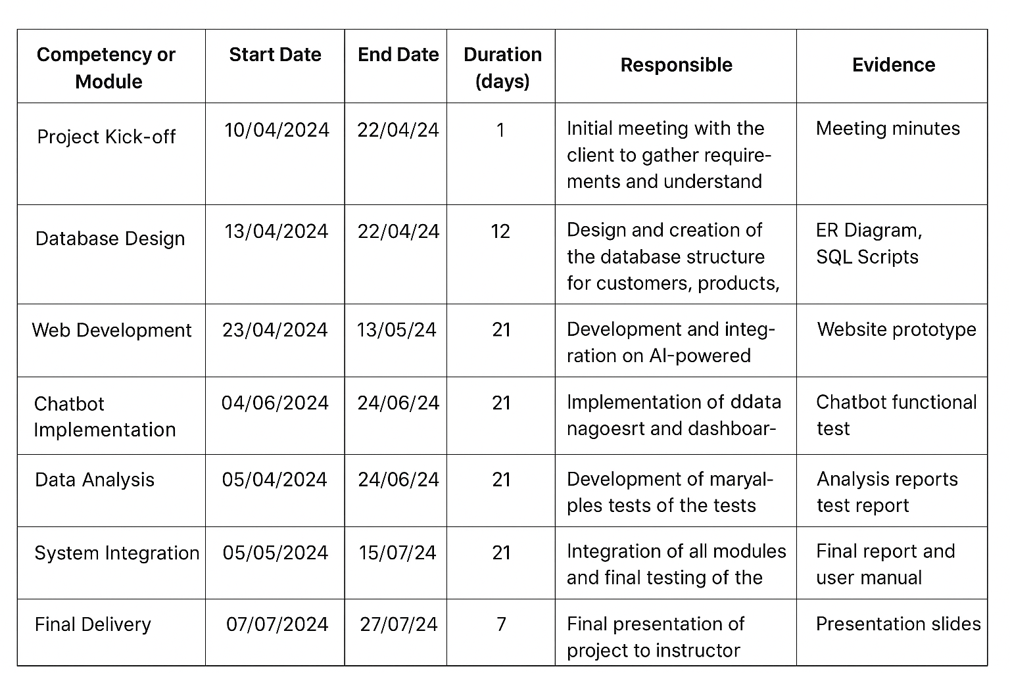

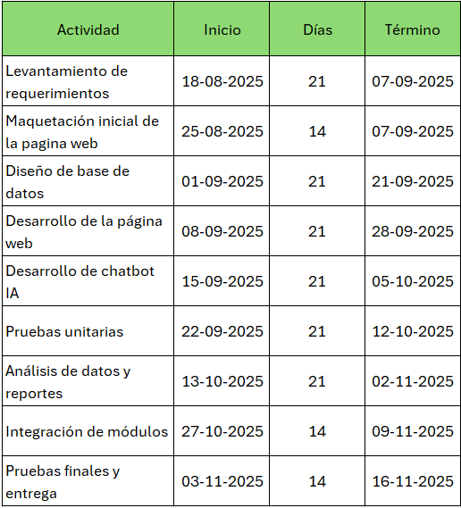
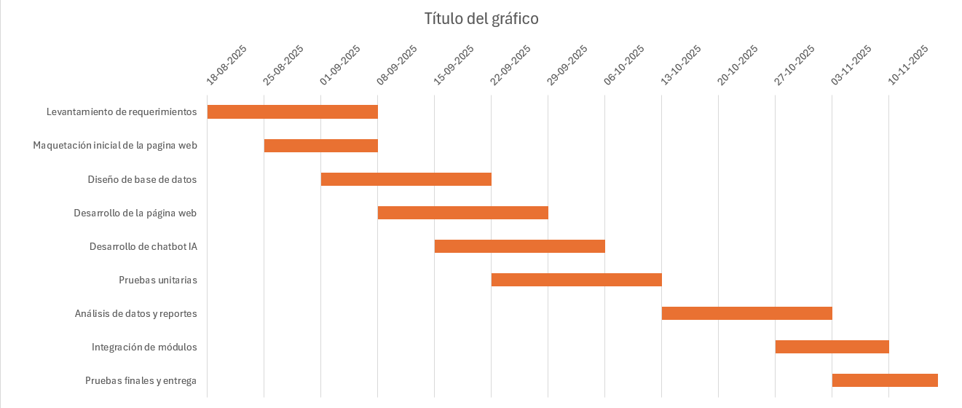
8. Gantt chart

